DAR – DEFENCE ADVANCE ROVER

Dr. MK Jayanthi Kannan

Professor and HOD

Information science and Engineering

FET, Jain (Deemed-to-be University) Bangalore-562112 [dr.mkjayanthi.ju@gmail.com](mailto:dr.mkjayanthi.ju@gmail.com)

Aman Kalavadia IV-B.TECH-ISE

FET, Jain (Deemed-to-be University) Bangalore-562112 [k6aman@gmail.com](mailto:k6aman@gmail.com)

Ayush Kumar IV-B.TECH-ISE

FET, Jain (Deemed-to-be University) Bangalore-562112 [ayushkumar982191@gmail.com](mailto:ayushkumar982191@gmail.com)

Holachi Vaishnavi IV-B.TECH-ISE

FET, Jain (Deemed-to-be University) Bangalore-562112 [vaishu.holachi@gmail.com](mailto:vaishu.holachi@gmail.com)

Sagar Katekhaye IV-B.TECH-ISE

FET, Jain (Deemed-to-be University) Bangalore-562112 [Katekhayesagar7@gmail.com](mailto:Katekhayesagar7@gmail.com)

Kaushik Wagh R IV-B.TECH-ISE

FET, Jain (Deemed-to-be University) Bangalore-562112 [Kaushikwagh21@gmail.com](mailto:Kaushikwagh21@gmail.com)

***Abstract - A Rover is a IOT based robot that is basically designed to detect Landmines, Smoke, Fire, Alignment, Obstacles, Radar to detect Movement. In this research we prepare a Rover as a prototype of multi-functional robot and the purpose of it is to go to dangerous areas like collapsed places, areas attacked by terrorists to collect every possible data of the situation and send it via wireless communication system (Remotely), as well as manually for the further actions. The main phenomenon of this Rover is to help army by providing various information which usually is difficult and risky for a person to collect and send it to the control center. The whole system operates wirelessly and send each and every data to the control center through signals, and shows live video footage directly to the control center, even if the camera is damage the remaining sensors keeps providing the data.***

***Keywords — IOT, Machine Learning, Robotics and Arduino algorithm.***

1. INTRODUCTION

Rover may be a moving platform or vehicle equipped with totally different electro-mechanical gadgets. it's a hybrid product of natural philosophy and mechanics. Rovers square measure principally used for assembling knowledge or materials from places wherever accessibility is poor or dangerous. Rovers contain totally different variety of sensors and even mechanical facilities for varied applications. Sensors square measure usually meant for detection physical conditions of the realm like heat, electrical shock, smoke or perhaps detection the presence of live physical body. fashionable rovers square measure equipped with computer code and small controllers for swish and correct functioning. The aim of the Rover is to drift around and provide video knowledge from the given atmosphere and to send that obtained knowledge to the user. With the obtained live streamed video output, the action of investigating is performed.

In 1954, humans were introduced to the world‘s first fully functioning industrial robot ―The Unmated" and after that, scientists and engineers have come together to create dynamic and diverse changes in the field of automation and robotics to make the daily humane tasks easier and faster. The use of robots in development and automation fields is increasing day by day and there is no doubt about the future being largely controlled by robots and artificial intelligence (AI).The Surveillance System closely observes and analyzes the surrounding and get instant information about the conditions. It is mainly required in areas of high risk, borders, public places, and prison or in industries which is mainly used for monitoring behavior and activities of a group or any

individual. The need of surveillance robots arises when the life risk is too high and the user wants the information to be highly accurate. Robots are nothing but fully automated electronic and internet controlled devices that are capable of performing various tasks that a normal human might not be able to do. Thus, use of robots for surveillance is one of the greatest advancements in the field of automation.

These multifunctional robots are able to perform tasks in dangerous situations like collapsing buildings or radioactive zones. One of its best uses is in the protection and rescue works after unexpected tragedy or unwanted invasions like Ukraine Russia Cold war or tragedies like Chernobyl/Bhopal Gas Plant. There are many obstacles faced by the rescue forces during inspection of such sudden and unexpected events like narrow spacing, collapsing of damaged structures.

It becomes difficult for an ordinary human to deal with such risky tasks to enter areas without knowing the present information. These robots being autonomous in nature are designed to perform efficiently without human interference and have high mobility. Back in 1999, Kevin Ashton introduced the term ‗Internet of Things to the world in one of his presentations.

IoT connected people with everything on the internet from anywhere around the world and since then the definition of IoT has evolved and growth has rapidly increased. Nowadays, we can see the wide use of IoT in various fields to connect the world virtually and physically. The number of devices connected via IoT as of 2021 are close to 30 billion and expected to react 75 billion in the year 2025 enumerated by Statista.

This IoT Based Autonomous multi-purpose surveillance and rescue robot is built on mainly two systems, the motorized working of the robot with all the connections and second, the communication of the device with the user and smooth data transfer from the sensors to the cloud platform.

These systems help in carrying out task properly. The main aim of this project is to combine the two different systems into one machine that would make them work simultaneously and perform the required tasks. To achieve this aim, an IoT based monitoring system is also included with the robot which can be used to monitor by the user through their device.

The main applications include:

1. Record video visuals and broadcast it to the user

2. Send data from sensors to the IoT channel

3. Can explore areas that are dangerous for human

4. Used for the inspection of border areas

1. LITERATURE SURVEY

Accurate matching of high-quality answers to provided questions is a major difficulty in Community-Based Question Answering assignments. Many older methodologies are likely to suggest related responses based solely on content similarities between questions and answers It is created based on the user's participation in the response to a relevant question. We assume that the user in the last position of the answer collection is referring to the previous user’s answer before posting their solution to the query. The power of user communities to collect, organize, and filter content here on the Internet has been demonstrated by projects such as Wikipedia. A variety of question and answer (Q&A) sites have recently succeeded in building a big, increasing knowledge base, each fueled by a diverse series of questions and responses from their user community.

The power of user communities to collect, organize, and filter content here on the Internet has been demonstrated by projects such as Wikipedia. A variety of question and answer (Q&A) sites have recently succeeded in building a big, increasing knowledge base, each fueled by a diverse series of questions and responses from their user community. - The main issue of a disaster place is that the delay to rescue the victims. In a disaster place, it became impossible to find the victim as soon as possible. the major reasons is the small number of technical rescuer teams. It‘s also difficult for the rescuers to go inside the rubble because of toxic gas, hazardous material, high temperature. Rescue mechanical technology has been recognized by the National Research Council's ponder "Making the Nation More secure.

The advent of new high-speed technology and the growing computer Capacity provided realistic opportunity for new robot controls and realization of new methods of control theory. This technical improvement together with the need for high performance robots created faster, more accurate and more intelligent robots using new robots control devices, new drivers and advanced control algorithms. This project describes a new economical solution of robot control systems .In general; the robots are controlled through wired network. The programming of the robot takes time if there is any change in the project the reprogramming has to be done. Thus they are not user friendly and worked along with the user preferences. To make a robot user-friendly and to get the multimedia tone in the control of the robot, they are designed to make user commanded work. The modern technology has to be implemented to do this.

Now- a-days industries are becoming modern and they automated the technology to perform various risky jobs. This robot is helpful to minimize the life risk of the humans and the animals. With the advance technologies of the wireless communication technology in robots there can be an autonomous robot car which will be controlled manually. Surveillance is the process of continuous monitoring of the territory which is essential for military security. Here the robot is controlled by using internet in PC or Android mobile phone through the webpage. And the camera present to the robot captures the data and sends the data to the controller through internet. An computerized surveillance robot is used for safety-conscious which includes at airports, museums and government installations and so on. The wise software should reveal security cameras and detects if any difficult behavior takes place. Having an automatic surveillance robotic vastly increases the productivity of the human operator and increases coverage of the surveillance so that human can do best the operation or navigation of robot alter natively getting damage in the wars.

Method: First, we have to make a robot by Node MCU through which the web page and the beagle bone black board microprocessor connects to the power supply. By using USB cabled camera module connected to the beagle bone black board and it shows the live streaming data in the system through the internet. It can give only online live streaming depending upon that we can navigate the motion of the robot. In our project we have used an 18megapixel camera for the image processing of the data through the web page and in the webpage, we will have the live streaming data and we can control the robot in the web page. Here, the Beagle Bone Black works with an operating voltage of 5v. The USB Camera is enabled with the USB host to give an input to the Beagle Board-x M processor. The operation of the Beagle Board-x M processor is to compress and quality image for determining the motion of the camera filed and then displayed on webpage.

With the various and fast advancements in the field of Automation and Robotics, robots are playing a vital role in simplifying the lives of human beings by reducing human errors and human labor. A surveillance robot is a robot used for spying/monitoring purposes. Any remote/inaccessible areas can be monitored using surveillance robots. Surveillance is the method of systematic close observation of person or area of suspicion. Surveillance is mainly required in the area of defense, intelligence gathering, disaster affected areas and in public places.

Nowadays, tracing, tracking and attacking enemy troops indifferent areas proves to be a tedious task for army personnel. There is always a chance of loss of the lives of soldiers on the battlefield and during emergencies. To develop a technology that serves the high speed and advanced capacity to control the robots and to devise new methods of control theory. To realize the above standards, some technical improvements along with the need for high-performance systems are required to create a faster, reliable, accurate and more intelligent robot. This can be devised by advanced control algorithms, robot control devices and new drivers. To meet the requirements, we can use multimedia to control the user-friendly robot.

Since the late 2019, the COVID-19 disease has been spread worldwide. It leads to critical challenges to almost all countries in the world. Until November 2020, there have been 57,639,631 confirmed COVID-19 cases with 1,373,294 deaths globally, according to the statistics of the World Health Organization (WHO) [1]. Different approaches and technologies are suggested to support the treatment and control of the pandemic, including robotics.

:- In today‘s world, the development of science and technology has introduced the concept of virtual reality and robotics. The term virtual reality means ‗near-reality‘. This concept enables people to be at more than one place at a single time. This robot enables to observe the people and their surrounding without being physically present. It helps one person feel more connected by giving a virtual presence where one can't give in physical. Robots have increased widely in today‘s world. In almost all industries, the concept of robotics is used as they are user friendly. The Robot used in this project uses a rechargeable battery. Telepresence uses virtual reality technology. The telepresence robot gives a virtual reality experience that can be felt by the user even

the working of the robot and capturing of the visuals by RPi camera, how to configure Wi-Fi and interfacing servomotors with Raspberry Pi and geared motors with Arduino. It explains how the data is received, as signals, from an android application and sent to Raspberry Pi and Arduino. The mini rover camera is stationary. As the rover moves, the camera moves along. In the proposed system, we have the facility to rotate the camera accord.

Building and industrial areas are commonly targeted by thief‘s and intruders putting the lives of humans or valuables at risk. Recently, robots have found to be useful to provide surveillance and prevent such unauthorized access from taking place. With the advent of mobile robots capable of solving complex tasks and achieving real-time decision-making capability, autonomous robot has become a norm. Autonomous Mobile Robot is a robot that can navigate by itself through an unknown environment. The AMR can sense its environment, create a model of it and localize itself within this environment. This enables the AMR to further create a navigation plan and dynamically execute this plan using a planning and path finding algorithm. This is known as Simultaneous Localization and Mapping. In a majority of SLAM based algorithms, some differentiable features in the map are noted as landmarks. When a robot moves across the map, the distances from these landmarks is taken as the feature extraction values for the robot to localize itself.In this study, an Autonomous Surveillance Robot which can map and indoor environment is designed and implemented. The Electronic design procedure has been explained in detail and functionality like video stream using a webcam, videorecording and speech recognition is implemented.

Surveillance is that the technique for perceptive a location, apart or someone for defense and security purpose. This activity continuously happens in an exceedingly military, police, public places and even in homes these days for watching and to regulate the dirty activities. We choose a rocker-bogie mechanism for our mechanisms a result of it's extremely stable suspension that is capable of operative in multi tract surfaces whereas keeping all wheels to bear with ground.

This mechanism is that the suspension arrangement employed in Mars rovers introduced for Mars expert and conjointly used on Mars Exploration Rover (MER) and Mars laboratory(MSL)) missions. the bogie will resist the mechanical failures caused by the cruel atmosphere on MARS. So as to travel over the obstacle, the front wheels are forced against the obstacle by the rear wheels. The rotation of the front wheel then lifts the front of the vehicle up and over the obstacle. the center wheel is that the ironed against the obstacle by the rear wheel and force against the obstacle by the front, till the upraised up and over.

Finally, the rear wheel is force over the obstacle by the front 2 wheels. throughout every wheel's traversal of the obstacle, forward progress of the vehicle is slowed or utterly halted. These rovers edge and climb over the obstacles by having wheels raise each bit of the suspension over the obstacle one portion at a time. This system uses an Spy camera as a watching camera. Six DC motors square measure every connected to the wheels and controlled via a Bluetooth module. This watching automaton will climb stairs simply as a result of it uses a rocker bogie suspension in order that the automaton will monitor the state of the complete area. Especially, the investigation activity is employed in the main for human as a result of the individuals were doing all bootleg work against the government and at identical time to safeguard them from those activities. The arrival of technology has brought a revolutionary modification within the field of AI, particularly in the automation sector. The usage of AI is increasing day by day, that reduces the human work however the efficiency of labor will increase altogether department from military to our home and even in hotels. Today ‘s life has modified a lot in each activity because of usage of Smartphone. The people can do all works victimization sensible phone and that they will operate any system by developing Associate in Nursing application, which may be put in the sensible and providing varied applications on different operative systems. Especially, the mechanical man OS is one of the necessary sources, that is on the market in open and helps in building the applying for several activities for people in their day these days life.

Result - The main aim achieved from this design is that all sensors are providing data accurately. Nanobot is also giving proper thermal imagining. While any sensors got logic ‗1‘ then all sensors start providing data. In this paper, we have divided the robot into three parts, which collect data from three perspective points & provide data to the rescuer team.

The Cool Robot supports long duration, autonomous science campaigns in polar regions through a unique low-profile solar-powered design coupled with simple navigation software and abuser interface that allows flexible selection of sampling protocols. We have two results i.e. the hardware and the software result. The hardware includes the robot which runs on DC motors. The input to the motors is provided by the L293D motor driver shield. The input to the driver shield is provided by the Arduino board. The navigational inputs are given by the user to the Arduino board using the android application via Bluetooth. The Arduino board, on receiving the signal, processes it and produces the appropriate output. The communication between the android application and the Arduino board takes place using the Bluetooth module which is interfaced with the Arduino board. It provides serial communication between the application and the Arduino.

In this Project, we have described overall design for a video streaming wheel robot which is controlled using Beagle Bone Black and a webpage created using HTML and JavaScript. This is mainly a surveillance robot which streams live video via camera module through internet and displayed on thewebpage which is used to control the robot movement. The robot ‘s movement is manual and can be monitored/controlled on the webpage. After the installation and setup of the beagle bone the following steps were used in order to run the project. Step-1: Updating of the image i.e. the camera tracks the live motion of the system and it updates the images or live stream to the webpage.

Step-2: The USB cable is included in the beagle bone which provides the convenient way to provide both power to Beagle and connected to the system. It should always be powered. The SD card inside the Beagle Bone ought to be inserted in a way that it’s far inserted in advance of impartingpower.USR0 is configured in the Beagle Bone at boot to blinking a heartbeat pattern. USR1 is configured in addition the mild in the course of the accesses of the SD cards.USR2 is configured besides the mild at some stage in CPU pastime.

Step-3: Enabling of network connection in the Beagle boneset up. A network adapter should be shown up if connected through USB. The access point password is used to defaultthe Beagle bone when the board includes the WIFI

This paper presents a multipurpose surveillance robot that can be used in military applications for both spying and detecting landmines. We can also use this robot for detecting hazardous gases during rescue operations where humans cannot get inside due to tight spaces.

In practice, digitalization and automation did not progress fast before 2020 due to multiple reasons. The cost of robots are high and the implementation is hesitating against the cheap labor. There are political and social concerns of the fear and unknown consequences, while some of the technologies are banned at the legal level. However, the pandemic crisis forced the digital transformation to some degree. Until late 2020, the pandemic was still not well controlled globally. Many automation devices and systems have been deployed worldwide to fight against the crisis. Robot is one of the promising devices as it provides physical functionalities with effective social distancing among the patients and the medical staff. In this work, the achievements of the robotics research during the pandemic is reviewed and discussed. To answer, the literature so far is analyzed based on the supporting technologies, while the TRL is identified. The future research trends and essential techniques are also addressed, including AI, 5 G, big data, wireless sensor network, HRC and haptic control to answer.

After the proper assembly of hardware and installing followed by running the required software we demonstrated that the telepresence surveillance robot can provide HD colored live video in a region and direction as per our requirement. This paper has presented on the robot and capturing of the visuals from RPi camera. The person watching visuals from camera the directional data are transferred as the head moves. In the case when the head moves very fast, the transfer data rate is high. This, in turn, requires the Raspberry Pi to process the data very quickly.

The app should be programmed in such a way that the Raspberry Pi board gets enough time to process the data and prove it as input to the servos. The currently designed robot is suitable to run over only smooth surfaces. The stronger body of the robot will allow it to run over rougher terrains. In the military, this robot can be sent for monitoring instead of a soldier. In this way, only the robot gets damaged and no life is lost even if there is an unexpected attack.

The robot can be used for surveillance in the house where the owner wants to keep an eye on his home. In Medical, when the doctor is not available to go on rounds, the robot can be used to check the state of the patient. They can even provide home care assistance to the elderly. The robot can be used in fire and rescue operations if it is made fireproof.

1. PROPOSED METHODOLOGY

First sensor & camera got power and turn on. Then quadcopter start mapping the area for 30 min. If any human live or smoke is detected while mapping it gives the location of that place immediately to the operator by sending an image. While quadcopter mapping the place rover also work simultaneously. To control sensors Arduino microcontroller is used. To control four-wheels of rover BTS7960 motor driver we have used and to control servo motors of mechanical claw & camera we have used servo motor driver module.

Rover can‘t be access until the RFID is not matched. If RFID matched then rover follows the path provided by the operator. While surveying the area if any sensor got logic 1 then microcontroller activate all the sensors. If any human or smoke is detected by these sensors, the n immediately alerts the authorities. Among all these if battery is less than 10%then operator gets a red light blinking and have to take back rover to the base station immediately. First quadcopter & camera got power and turn on. Then quadcopter start mapping the area for 30 min. If any human live or smoke is detected while mapping it gives the location of that place immediately to the operator by sending an image. While quadcopter mapping the place rover also work simultaneously.

To control sensors Arduino microcontroller is used. To control four-wheels of rover BTS7960 motor driver we have used and to control servo motors of mechanical claw & camera we have used servo motor driver module. Rover can‘t be access until the RFID is not matched. If RFID matched then rover follows the path provided by the operator. While surveying the area if any sensor got logic 1 then microcontroller activate all the sensors. If any human or smoke is detected by these sensors, then immediately alert the authorities. Among all these if battery is less than 10% then operator get a red light blinking and have to take back rover to the base station immediately. Adding to it this rover framework is also enabled with live streaming of the area, which can be easily seen on any android device or laptop on a webpage which will be enabled when we start the rover, It is also enabled with state of the art ultra-sonic sensors which help in collecting trash when any person is near the dustbin in simple terms if you want throw garbage manually in the dustbin you can go near the dustbin and the sensors will detect your presence, and by this the lid of the top dustbin will open and you can put your trash into it. So our Framework in Simple words not only terms of segregating and collecting garbage but also helps in the surveillance.

This class of robots can be designed by following below mentioned methodologies

1. Choosing a rugged mechanical chassis.

2. Choosing a stable computational core for managing the robot.

3. Sensing physical world parameters for offering services. The above methods can be integrated into a system which serves the purpose of a smart IoT based Robot.

Designed to detect Landmines, Smoke, Fire, Alignment, Obstacles, Radar to detect Movement. In this research we prepare a Rover as a prototype of multi-functional robot and the purpose of it is to go to dangerous areas.

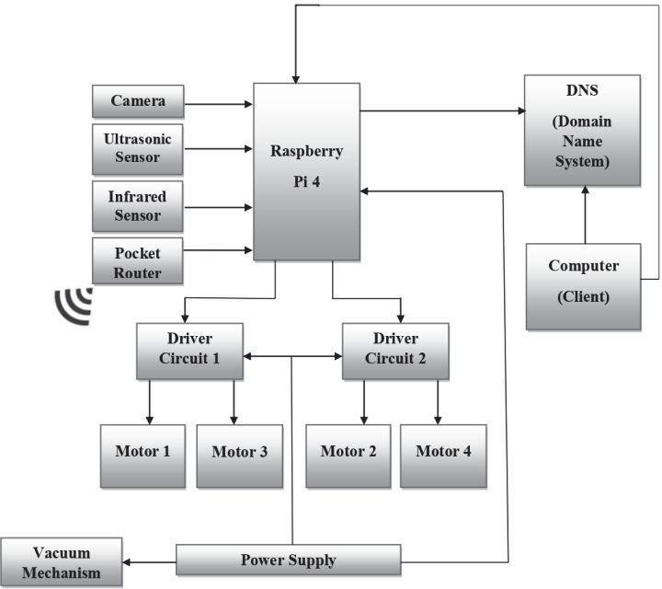

Figure. 3.1. Raspberry pi implementation

1. *Mechanical Design and Chassis*

Fundamentally, for any mobile robot whether on land, in air or under water is a mechanical base or platform actuated by electric motors. A commercial plastic-based trashcan with lid, sizes roughly around 12-14 inches wide and 32-40 incheshigh. This bin is partition into two parts, upper and lower respectively. Lower part is assembling with prototype vacuum cleaner and upper part is again partition into left and right. Left upper part is for wet waste and right upper part is for dry waste respectively covered with same lid integrated with ultrasonic sensors. The vacuum cleaner is mounted in such a way that it should be near to ground and necessary space and vents can be used to improve cooling.

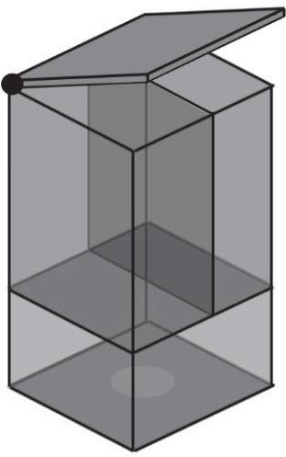

Figure. 3.2. Design And Chassis

1. *Computational Core*

To be able to handle all computation, processes and sensor data acquisition and cost-effective board like Raspberry Pi 4B is required. It‘s full-fledged SoC (System on-chip) capable of connecting to local network/Internet via its gigabit Ethernet. The fan-less architecture doesn‘t require much power to operate. We used Raspbian OS based on Linux which can run python tools for simple yet powerful user-friendly applications – video stream. It comes with bunch of General-Purpose Input and Output pins or GPIO for short so that we can easily interface a good number of sensors to sense the physical world parameters. C. Sensing Dynamic Environment: The smart trashcan should be able to sense waste in it and provide uninterrupted service, long range infrared distance sensors can be used to know the trash status in bin by calculating distance and alerting client on overflow. In each partition separate infrared sensors are used. To automatically open trashcan lid servo- motor and ultrasonic sensor are connected with digital pins. Raspberry pi acquires video, images and stream it remotely to client on web application.

1. System Implementation

After getting all hardware & rugged chassis for rover, firstly we connect GPIO pins with L298N‘s H-bridge driver circuit input pins and ultrasonic sensors pins. The fundamental block diagram shows connection of various components. A pocket router or dongle is connected to Raspberry Pi 4B for network connectivity, Raspberry Pi acts as web server. For optimized performance we have used recommended operating system distribution called Raspbian OS as it is specifically designed for Raspberry Pi. To remotely access this system, we need static IP (Internet Protocol) address, but pocket router or dongle doesn‘t provide static address instead it provides dynamic IP. To resolve this problem DDNS (dynamic domain name server) is used, which possesses more satisfactory functions and is easy to develop and convenient for use. A DUC (Domain Update Client) service runs in background in Raspberry Pi which automatically updates current IP address of Raspberry pi provided by service provider with domain name. These allow us to access robot remotely using domain name.

1. *Activity Monitoring*

The user can able to access the robot with wheel drive control buttons on the webpage. The web application is developed on MVC (Model View Controller) Python-Flask framework. The webpage can be used to monitor and control the robot by displaying nearby video, and to decide the direction of the robot to go. The Raspberry Pi GPIO (General Purpose Input and Output) pins are connected to L298N‘s driver circuit, so when user clicks on buttons corresponding macro is called from the python script resulting in the corresponding GPIOs being made LOW or HIGH. The Raspberry pi Camera V1 is 5MP static sensitive type camerais used. The Raspberry pi camera continuously captures the image and it is saved on the SD card of the Raspberry pi module as well as video stream displayed remotely on web application. The video stream is in gray-scale format. The gray-scale image format was chosen because video-frames in gray-scale format is much faster to stream and consumes one-third of the bandwidth required for streaming same video-frames in RGB or any other color format similar to RGB format. To monitor status of squander in trash bin an infrared sensor is used in each partition.

The device emits an infrared radiation and receives the radiation which isreflected back from the target object. The sensor measures the distance to the target object by measuring time between emission and reception of the infrared radiation. It uses single infrared element for both emission and reception.

On trash bin overflow, an alert message is sent to user remotely so that user can dispose the squander manually. Trash collecting bin lid's open automatically, so visually Impaired and crippled individuals can adequately utilize it. An ultrasonic sensor is mounted beneath the lid which perceives any article like a hand for example, and command servo-motor to open lid. After certain time lid closes automatically if no article is being sensed. The sensor measures the distance to the target object by measuring time between emission and reception of the wave.

1. Calculate Using The Formulae

Distance (L) = 1/2*T*C

Where L is the distance of the object from the sensor, T is the time between emission and reception, and C is the acoustic velocity, c = 340 m/s of ultrasonic wave.

1. Implementation

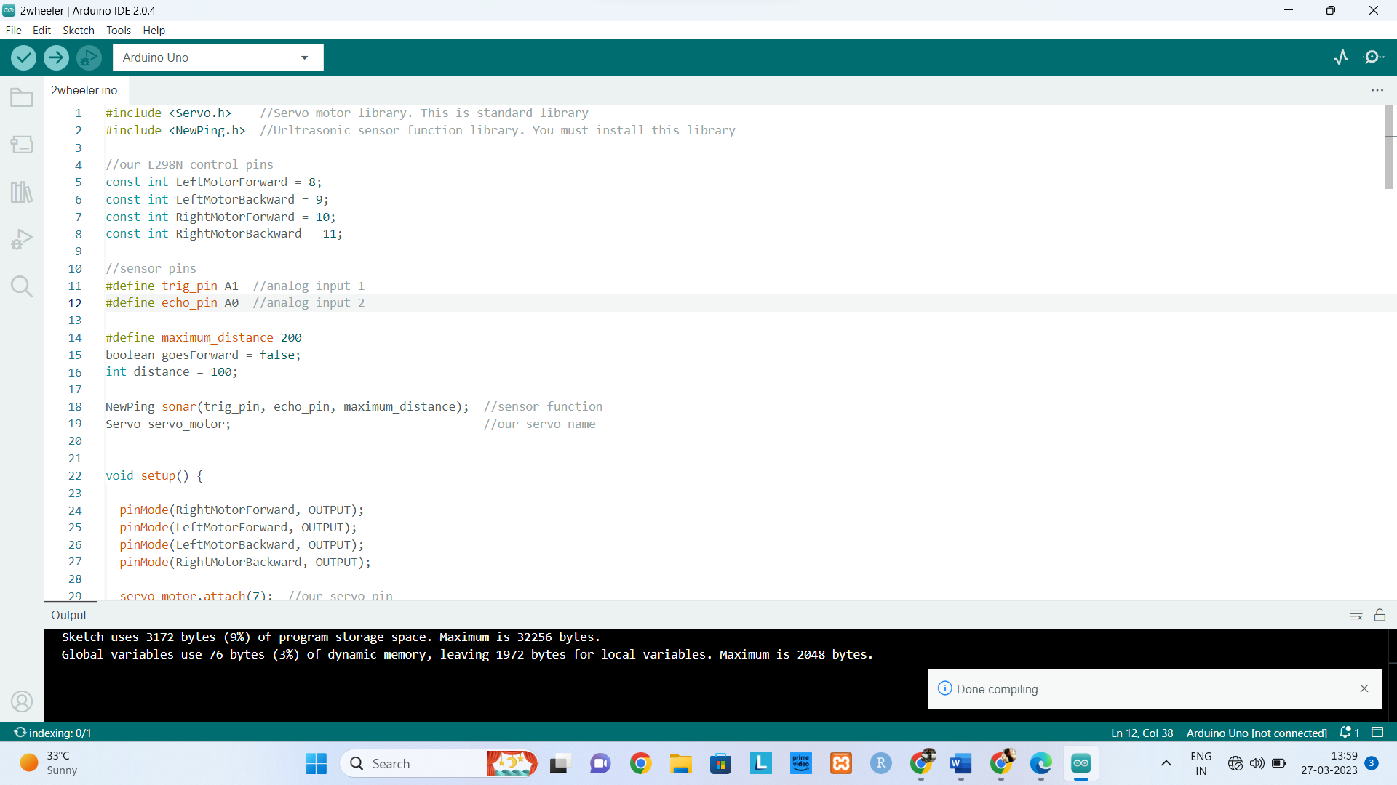

#include <Servo.h>//Servo motor library. This is standard library

#include <NewPing.h>//Ultrasonic sensor function library. You must install this library

1. *Hardware Components*

I. Raspberry Pi: Model is the third generation Raspberry Pi. This powerful credit-card sized single board computer can be used for many applications and supersedes the original Raspberry Pi Model B+ Model B. Whilst maintaining the popular board format the Raspberry Pi 3 Model B brings you a more powerful processer, 10x faster than the first generation Raspberry Pi. Additionally, it adds wireless LAN & Bluetooth connectivity making it the ideal solution for powerful connected designs.

II. Node MCU / UNO:NodeMCU is a low-cost open source IoT platform. It initially included firmware which runs on the ESP8266 Wi-Fi SoC from Espressif Systems, and hardware which was based on the ESP-12 and Arduino Uno is a microcontroller board based on the ATmega328P (datasheet). It has 14 digital input/output pins (of which 6 can be used as PWM outputs), 6 analog inputs, a 16 MHz ceramic resonator (CSTCE16M0V53-R0), a USB connection, a power jack, an ICSP header and a reset button. It contains everything needed to support the microcontroller; simply connect it to a computer with a USB cable or power it with a AC-to-DC adapter or battery to get started.

III. Sonic echo sensors x2:sensor is an instrument that measures the distance to an object using ultrasonic sound waves. An ultrasonic sensor uses a transducer to send and receive ultrasonic pulses that relay back information about an object‘s proximity.

IV.Smoke detection sensor:smoke detector is a device that senses smoke, typically as an indicator of fire. Smoke detectors are usually housed in plastic enclosures, typically shaped like a disk about 150 millimeter (6 in) in diameter and 25 millimeter (1 in) thick, but shape and size vary. Smoke can be detected either optically (photoelectric) or by physical process (ionization). Detectors may use one or both sensing methods.

V. IR sensor:An infrared (IR) sensor is an electronic device that measures and detects infrared radiation in its surrounding environment. Infrared radiation was accidentally discovered by an astronomer named William Herchel in 1800.

VI. Rover Chassis:Hard Structure

VII. RFID reader:A radio frequency identification reader (RFID reader) is a device used to gather information from an RFID tag, which is used to track individual objects. Radio waves are used to transfer data from the tag to a reader.

VIII. DC motor:DC motor is any of a class of rotary electrical motors that converts direct current (DC) electrical energy into mechanical energy. The most common types rely on the forces produced by induced magnetic fields due to flowing current in the coil. Nearly all types of DC motors have some internalmechanism, either electromechanical or electronic, to periodically change the direction of current in part of the motor.

IX. Servo Motor:A servomotor is a rotary actuator or linear actuator that allows for precise control of angular or linear position, velocity and acceleration.[1] It consists of a suitable motor coupled to a sensor for position feedback. It also requires a relatively sophisticated controller, often a dedicated module designed specifically for use with servomotors.

X. Metal detector:A metal detector is an instrument that detects the nearby presence of metal. Metal detectors are useful for finding metal objects on the surface, underground, and under water. The unit itself, consist of a control box, and an adjustable shaft, which holds a pickup coil, which can vary in shape and size.

XI. Vision Sensor: Vision Sensors/Machine Vision Systems analyze images to perform appearance inspections, character inspections, positioning, and defect inspections.

XII. PIR: The passive infrared sensor that measures infrared light radiating from objects. PIR sensors mostly used in PIR-based motion detectors. PIR sensor can detect animal/human movement in a requirement range. PIR is made of a pyroelectric sensor, which is able to detect different levels of infrared radiation.

XIII. Camera: Arducam Cameras

XIV. Battery: ESP8266

Figure. 4.2. Use Case Diagram

1. *Software Components*

I. ARDUINO IDE: Contains a text editor for writing code, a message area, a text console, a toolbar with buttons for common functions and a series of menus. It connects to the Arduino hardware to upload programs and communicate with them.

## II. RASPBERRY PI OS(C++ & PYTHON):

III. Geany is a powerful and lightweight development environment for Raspberry Pi. It's essentially a text editor coupled with GTK+ plugin and Scintilla library support that you can use to write code

IV. BlueJ is a popular IDE for those just starting out with Java. It has a simple interface that is easy to use, which makes it ideal for SBCs like Raspberry Pi. Besides, BlueJ also supports the Stride programming language that combines the best of both block-based and text-based systems.

V. Thonny is the perfect IDE for Pi if you want to code in Python. It's easy to use and comes with Python 3.7 built-in. If you're new to Python and want to create a basic program with it, Thonny offers a clean, vanilla interface. This helps to ensure that you don't get bogged down with all the fancy features — like the ones found on most IDEs — and focus on getting your code right.

*C. Output*

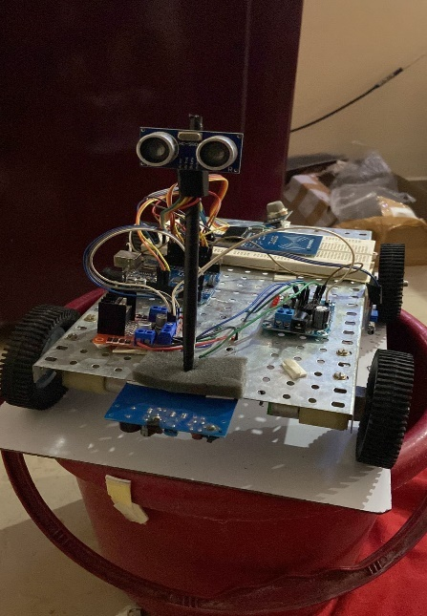

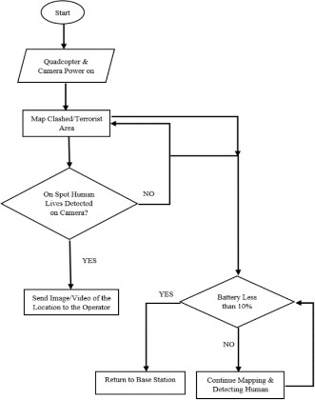Figure. 4.1. Final Output

1. CONCLUSION

Capable of going places where neither humans nor normal rovers can go. Can be used in combat situation (not intense). Can perform actions in stealth. Self operated by AI with a option of manual operation. Can be easily camouflaged. Has an multipurpose mount that can be used to mount cameras semi and fully automatic gas and tear gas ejectors. Is able to perform all the functions of CBRN mini UGB.

REFERENCES

[1]. Mohammad Shoeb Shah, Borolo. P.B. ―Surveillance and Rescue Robot Using Android Smart Phone And Internet‖. International Conference on Communication And Signal Processing, India (2016) .

[2]. Dr. Shaik Mahaboob Basha, Abdul Khayyum. S.K, Amarendra.B, Sajid.S.K. ―Design Of Security Robot in Night Vision Using Wireless Video Camera And Ultrasonic Sensor‖ Geethanjali Institute of Science And Technology, Nellore, Andhra Pradesh, India (2017) .

[3]. T.M. Sobh ; R. Sanyal ; Bei Wang, ―Remote surveillance via webcontrolled mobile robots‖, Proceedings World Automation Congress, 20 June 2004 , Seville , Spain.

[4]. Title: Surveillance Rover for Scientific ApplicationsAuthor name: EVANGELINE ASHA. B Published year: 2018

[5]. A. Al Arabi, H. Ul Sakib, P. Sarkar, T. P. Proma, J. Anowar and M. A. Amin, "Autonomous Rover Navigation Using GPS Based Path Planning," 2017 Asia Modelling Symposium (AMS), Kota Kinabalu, 2017

[6]. A. U. Bokade and V. R. Ratnaparkhe, "Video surveillance robotcontrol using smartphone and Raspberry pi," 2016 InternationalConference on Communication and Signal Processing (ICCSP),Melmaruvathur, 2016, p

[8]. R. M. Patil, R. Srinivas, Y. Rohith, N. R. Vinay and D. Pratiba, "IoTEnabled Video Surveillance System Using Raspberry Pi," 2017

2ndInternational Conference on Computational Systems and InformationTechnology for Sustainable Solution (CSITSS), Bangalore, 2017

[9]. Raut, Archit. (2020). Internet Controlled Techrobot using RaspberryPi. International Journal of Engineering Research and. V9.10.17577/IJERTV9IS080275.

[10]. N. H. Kamarudin, A. A. A. Rahim, N. E. Abdullah, I. S. A. Halim andS.L.M. Hassan, "Development of Automatic Waste Segregator withMonitoring System," 2019 4th International Conference onInformation Technology, Information Systems and ElectricalEngineering (ICITISEE), Yogyakarta, Indonesia, 2019

[11]. S. Saha et al., "GPS based smart spy surveillance robotic systemusing Raspberry Pi for security application and remote sensing," 20178th IEEE Annual Information Technology, Electronics and MobileCommunication Conference (IEMCON), Vancouver, BC, 2017,

pp.705-709, doi: 10.1109/IEMCON.2017.8117239.

[12]. B. Zhou, Y. Li, D. Li, W. Lu, S. Shen, G. Fang, Y. Su andS. Dai, "Initial Laboratory Field Tests of the Rovermounted GPR", 201817th International Conference on Ground PenetratingRadar (GPR), 2018

[13]. F. Krebs, L. Larsen, G. Braun and W. Dudenhausen,"Design of a multifunctional cell for CFRPproduction", The International Journal of AdvancedManufacturing Technology, vol. 85, no. 1-4,2014.

[14]. B. Drake, S. Hoffman and D. Beaty, "Rover, Design Reference Architecture 5.0", 2010 IEEEAerospace Conference, 2010.

[15]. W. Hartmann and G. Neukum, "Cratering Chronology andthe Evolution of Mars", Space Sciences Series of ISSI, pp.165-194, 2001.

[16]. B. Ayhan, M. Dao, C. Kwan, H. Chen, J. Bell and R. Kidd,"A Novel Utilization of Image Registration Techniques toProcess Mastcam Images in Rover With Applicationsto Image Fusion, Pixel Clustering, and AnomalyDetection", IEEE Journal of Selected Topics in AppliedEart88h Observations and Remote Sensing, 2017.

[17]. F. Zhou, R. Arvidson, K. Bennett, B. Trease, R.Lindemann, P. Bellutta,K. Iagnemma and C. Senatore,"Simulations of Rover Traverses", Journal of FieldRobotics, 2013.

[18]. F. Krebs, L. Larsen, G. Braun and W. Dudenhausen,"Design of a multifunctional cell Rover production", The International Journal of AdvancedManufacturing Technology, 2014.

[19]. B. Drake, S. Hoffman and D. Beaty,Design Reference Architecture 5.0", 2010 IEEE, 2010.

[20]. W. Hartmann and G. Neukum, "Cratering Chronology", Space Sciences Series of ISSI, 2001.

[21]. B. Ayhan, M. Dao, C. Kwan, H. Chen, J. Bell and R. Kidd,"A Novel Utilization of Image Registration Techniques toProcess Mastcam Rover With Applicationsto Image Fusion, Pixel Clustering, and Anomaly Detection", IEEE Journal of Selected Topics in AppliedEart88h Observations and Remote Sensing, 2017.

[22]. F. Zhou, R. Arvidson, K. Bennett, B. Trease, R.Lindemann, P. Bellutta, K. Iagnemma and C. Senatore,"Simulations of Rover, 2013.